Release Notes

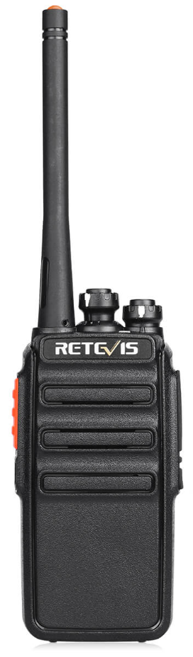

Table of Contents
Version v1.0.0 3

Version v1.0.0
Version | v1.0.0
Author | Samuel Netherway
Release Date | 06/10/2020
Changes | None, initial config.
Compatibility | RT24
Important Details | See RT24 Radio Configuration Table.xlsx for frequencies and configurations.

